**Project Report Template**

**1.INTRODUCTION:-**

**1.1 Overview**

The Human Resource Manager will lead and direct the routine functions of the Human Resource (HR) department including hiring and interviewing staff, administering pay, benefits, and enforcing company policies and practices.

**\*.**Recruits, interviews, hires, and trains new staff in the department.

**\*.**Oversees the daily workflow of the department.

**\*.**Provides constructive and timely performance evaluations.

**\*.**Handles discipline and termination of employees in accordance with company policy.

**1.2 Purpose**

Partners with the leadership team to understand and execute the organization’s human resource and talent strategy particularly as it relates to current and future talent needs, recruiting, retention, and succession planning. Provides support and guidance to HR generalists, management, and other staff when complex, specialized, and sensitive questions and issues arise.

Maintains knowledge of trends, best practices, regulatory changes, and new technologies in human resources, talent management, and employment law. Performs other duties as assigned.

**2. Problem Definition & Design Thinking:-**

**2.1 Empathy Map**



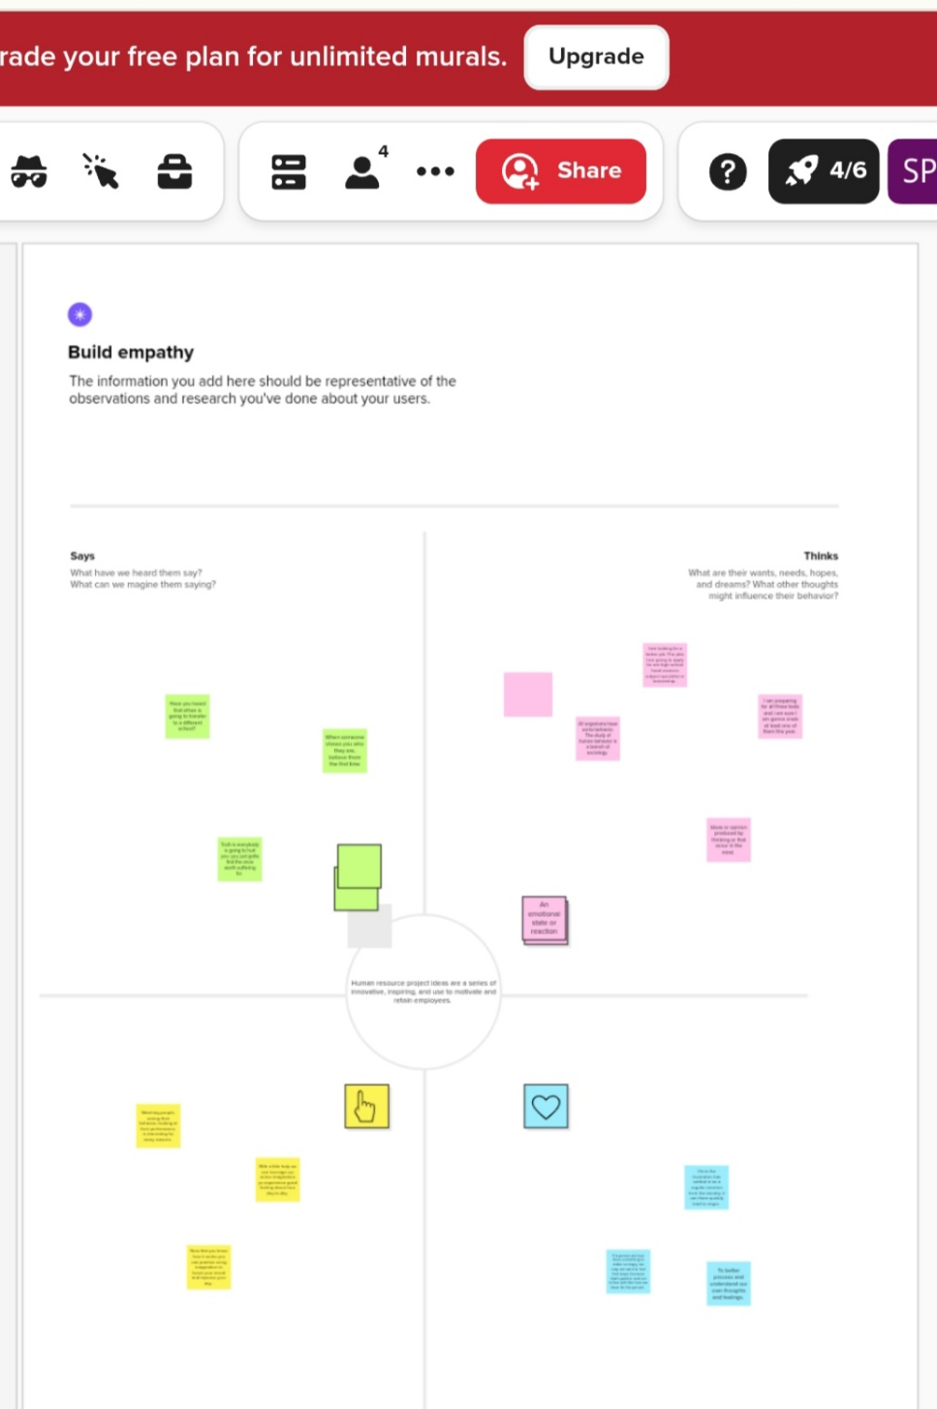

**2.2 Ideation and Brainstorming map Screenshot:-**

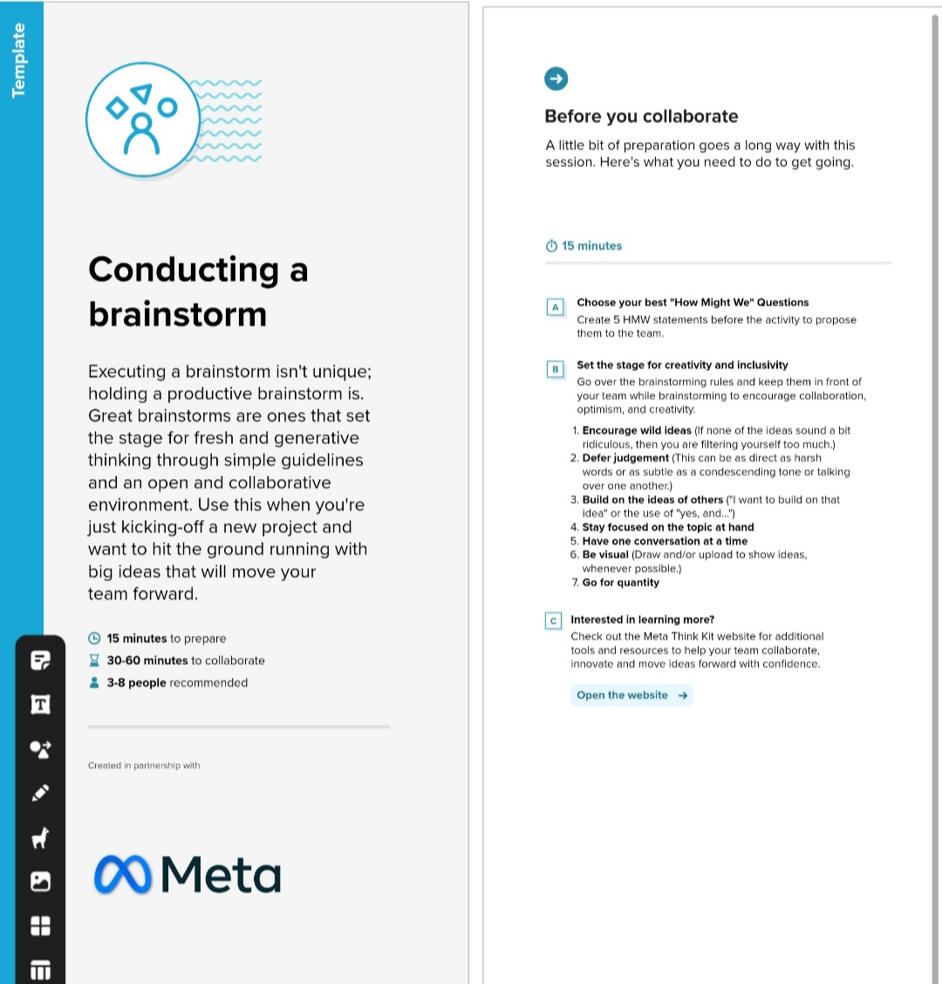

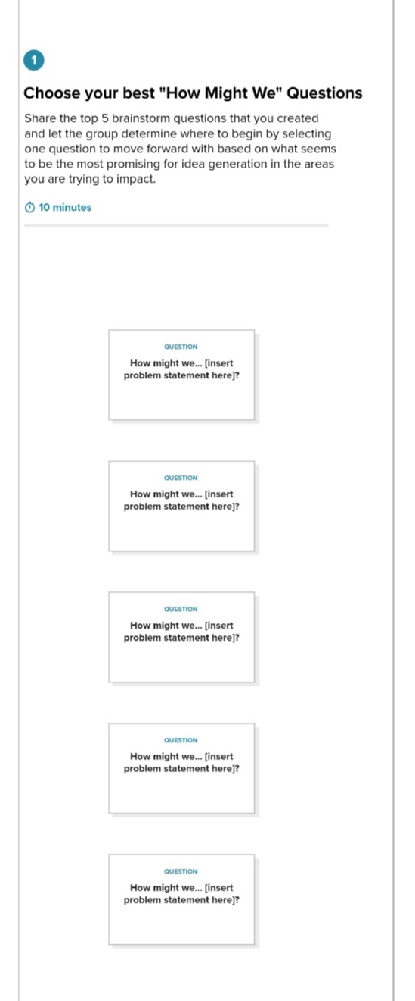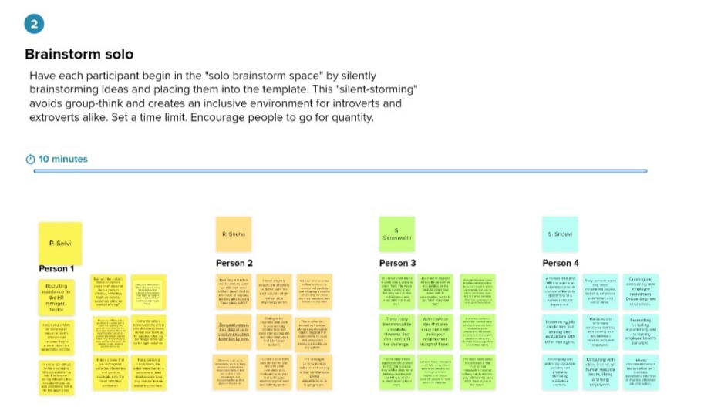

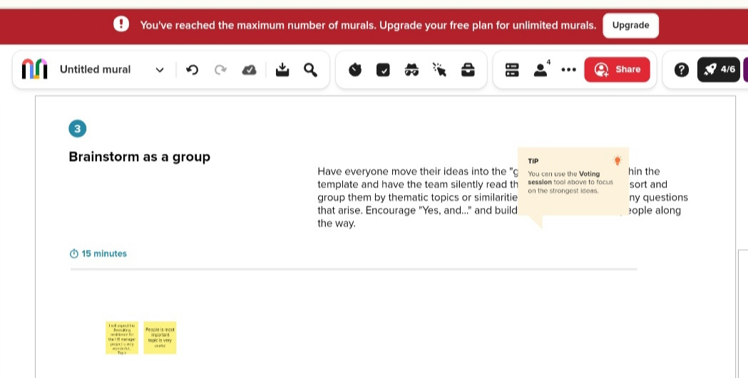

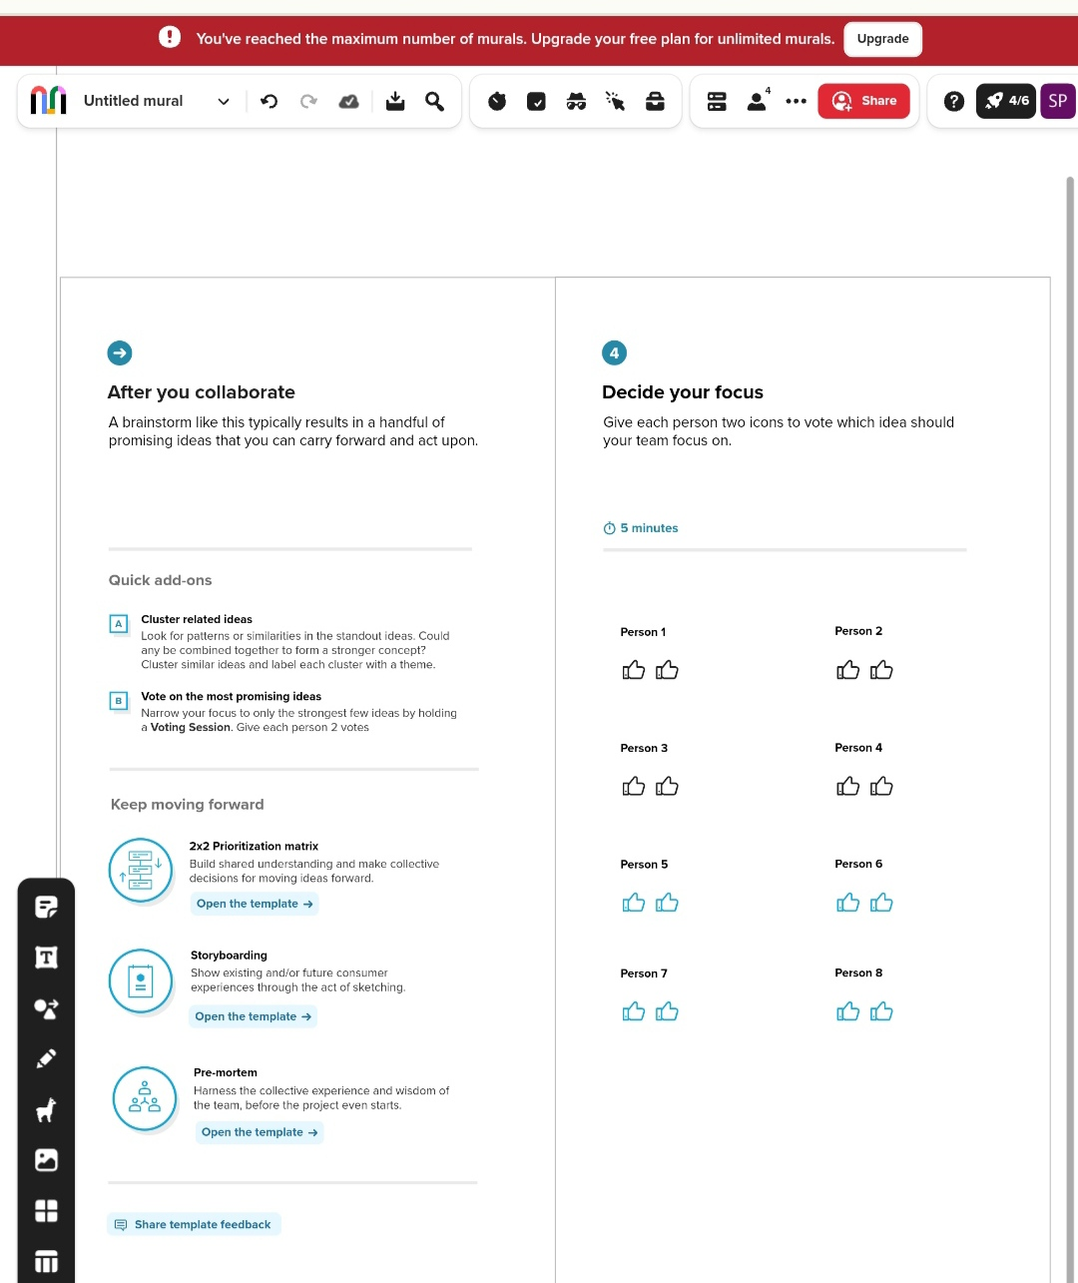

**3.RESULT:-**

3.1 Data Model:

|  |  |
| --- | --- |
| Object Name | Fields in the Object |
| Object-1 | Field Label: Phone Number  Data Type: Phone |
| Object-2 | Field Label: Sales Manager  Data Type: Employee |
| Object-3 | Field Label: HR skill  Data Type: Interpersonal |
| Object-4 | Strong analytical skill |
| Object-5 | Written Communication Skill |

3.2 Activity and Screenshot:

Create salesforce org-creating Developer Welcome Page:



Create a Salesforce Org-creating Developer of Home:

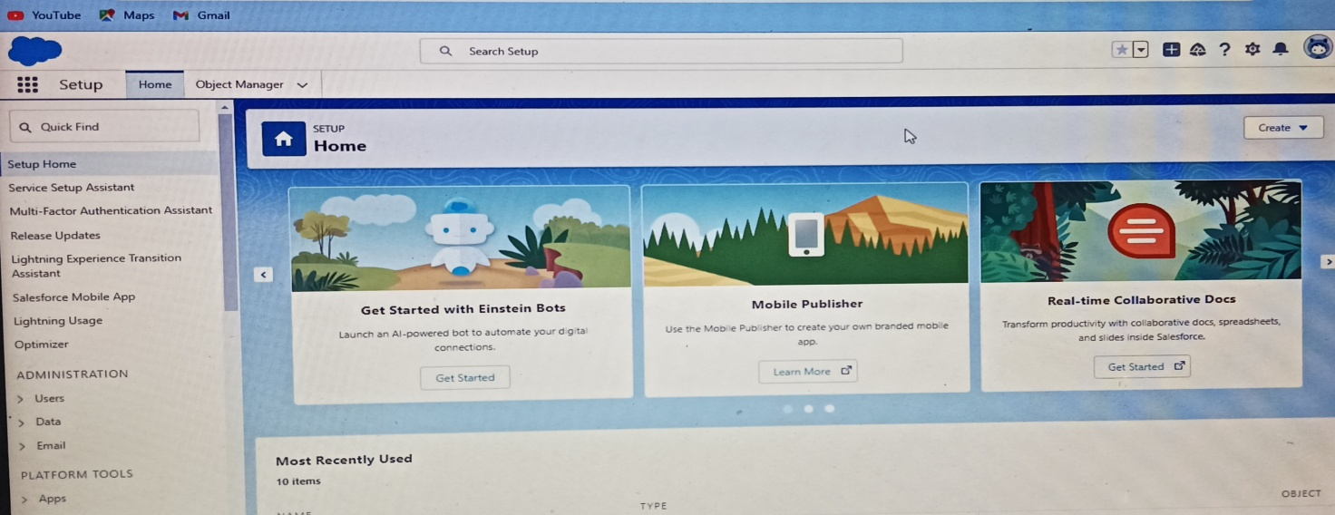

Creation of Account for Field & Relationship:

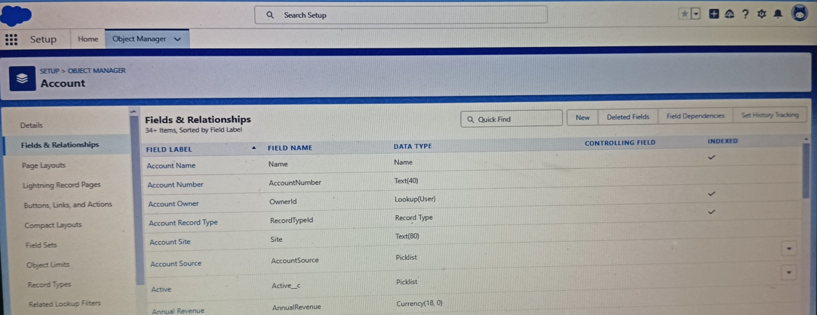

Creation of Sales:

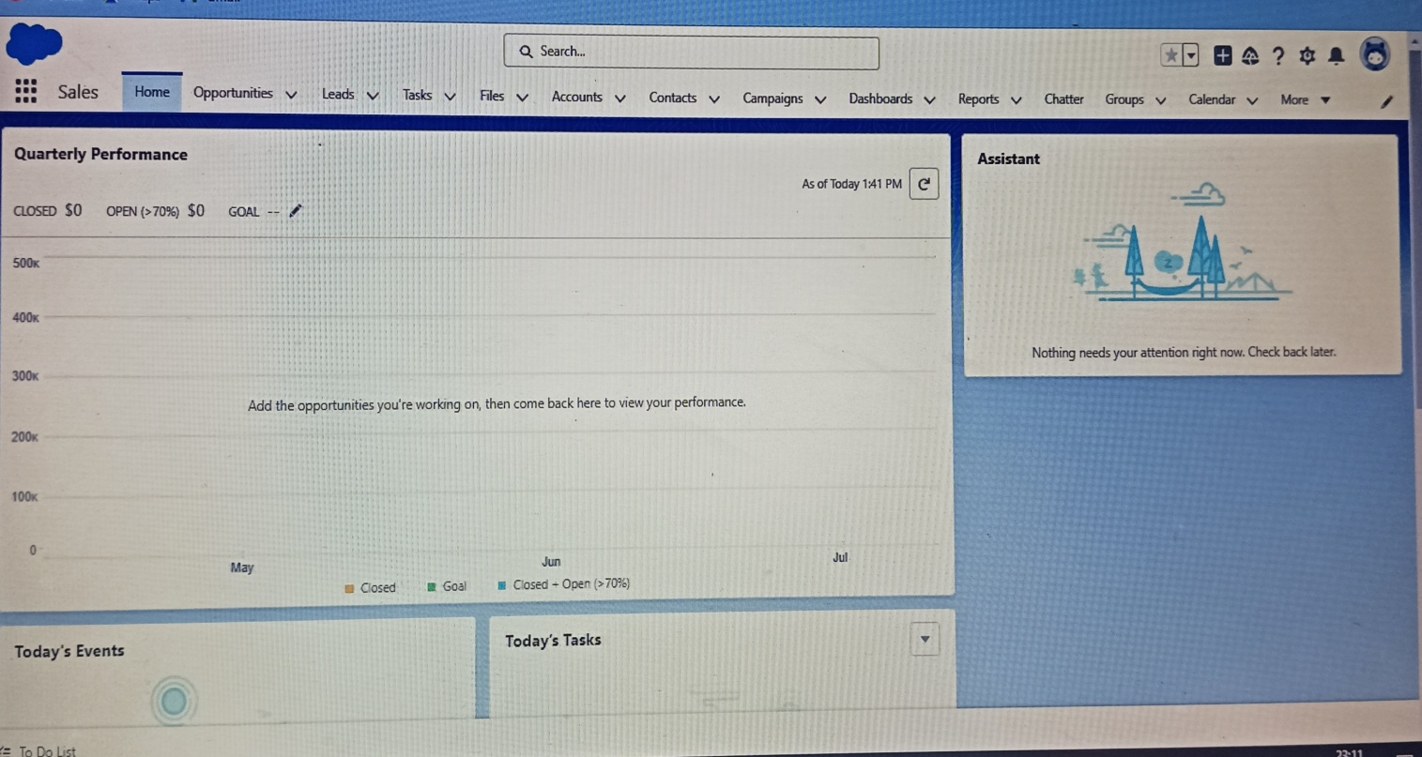

Creation of Opportunities:

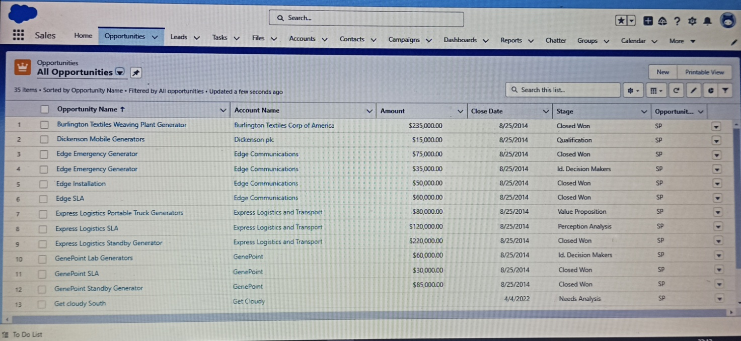

Creation of Contacts:

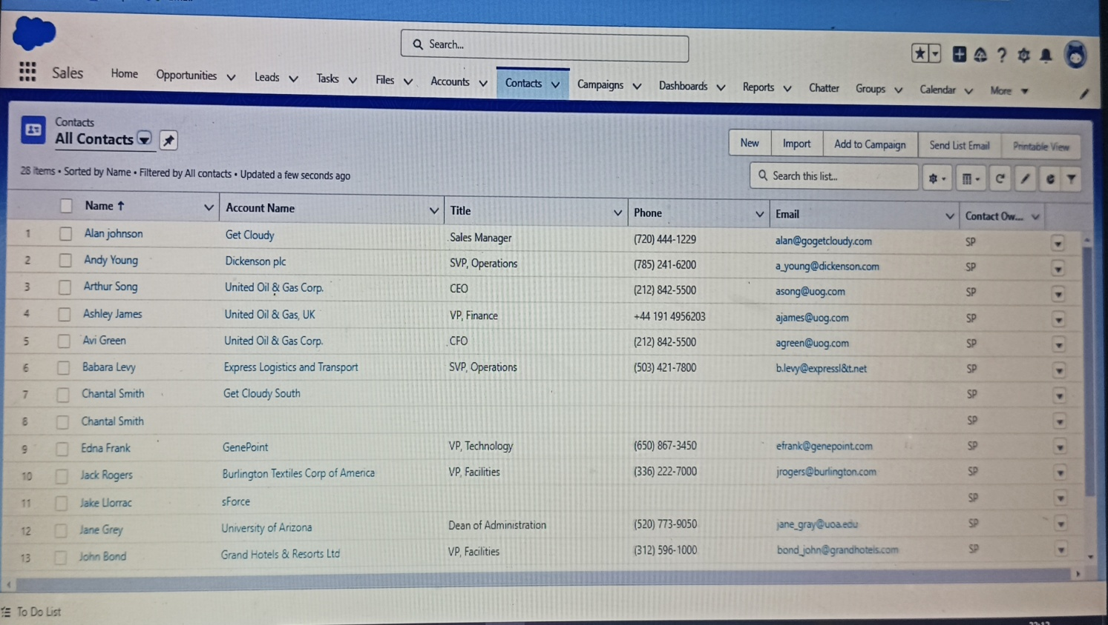

Creation of Reports:

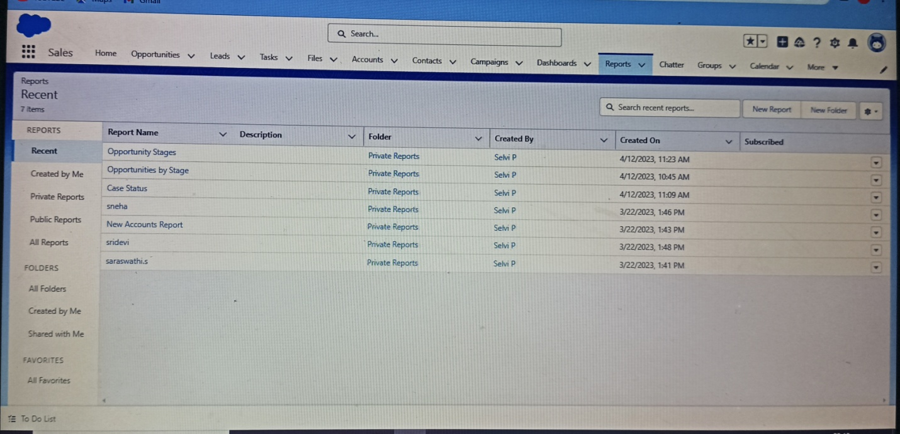

Creation Of App Launcher:

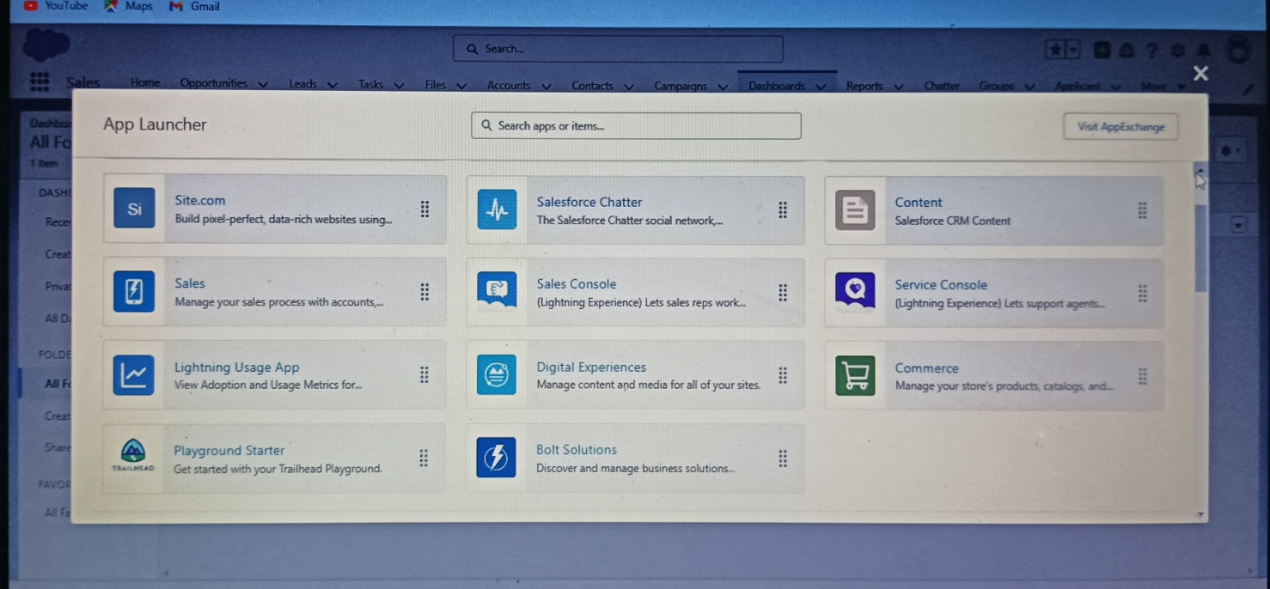

Profile

Creation On Profile:

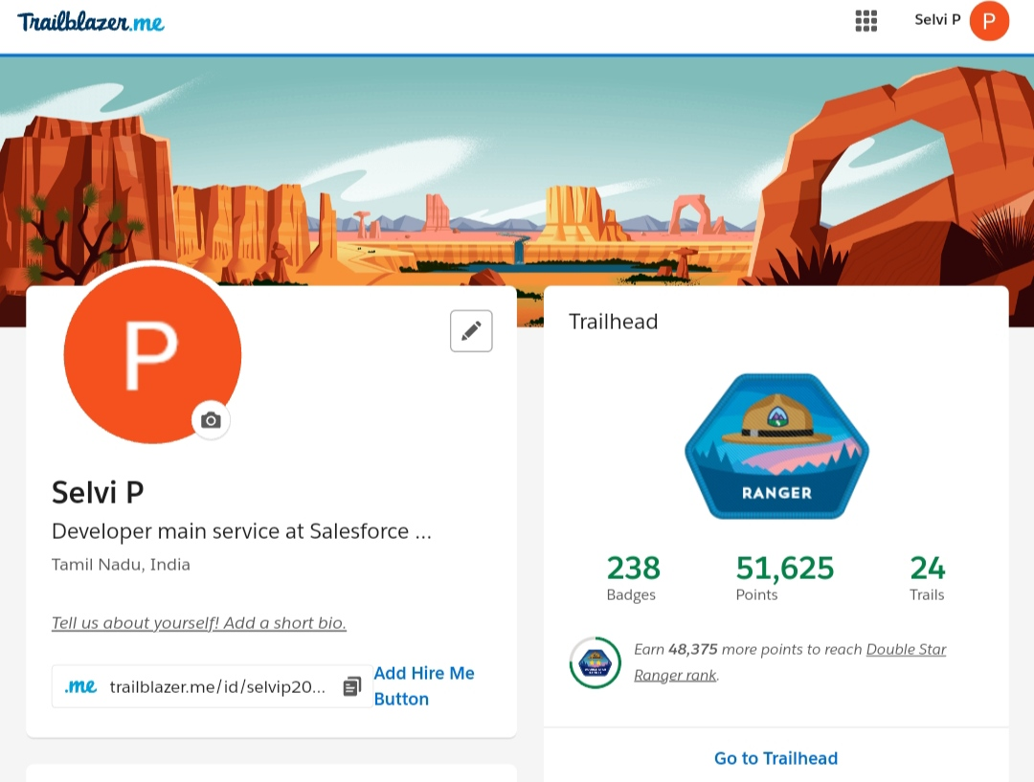

Creation of Salesforce Adoption Dashboards:

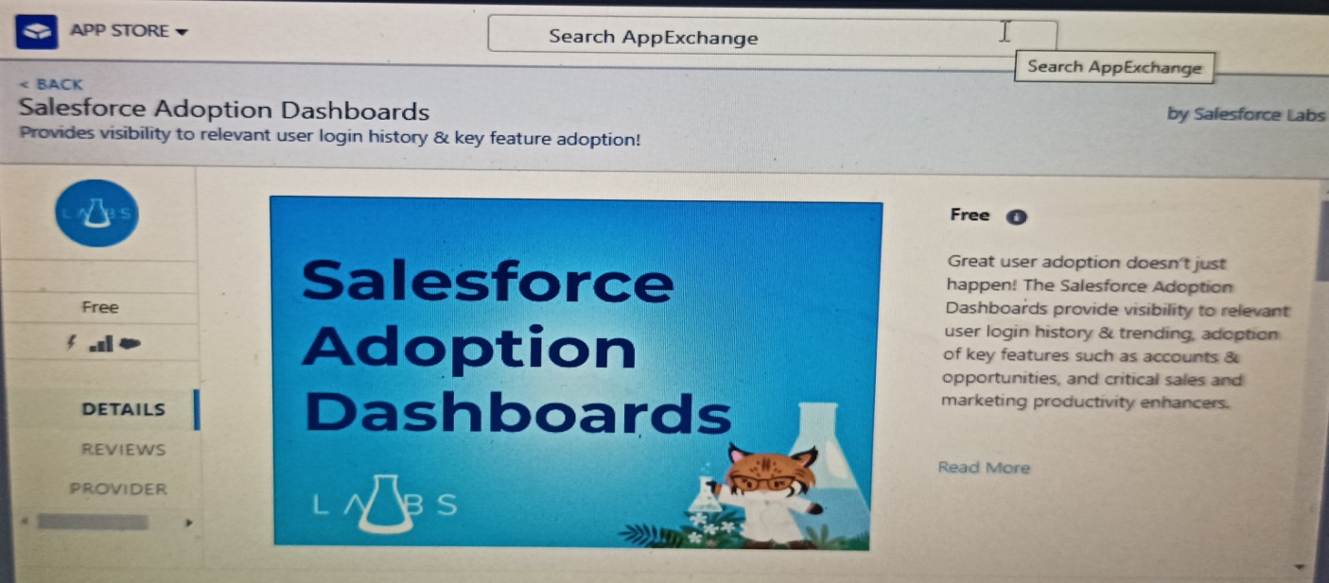

Creation of Services set up home:

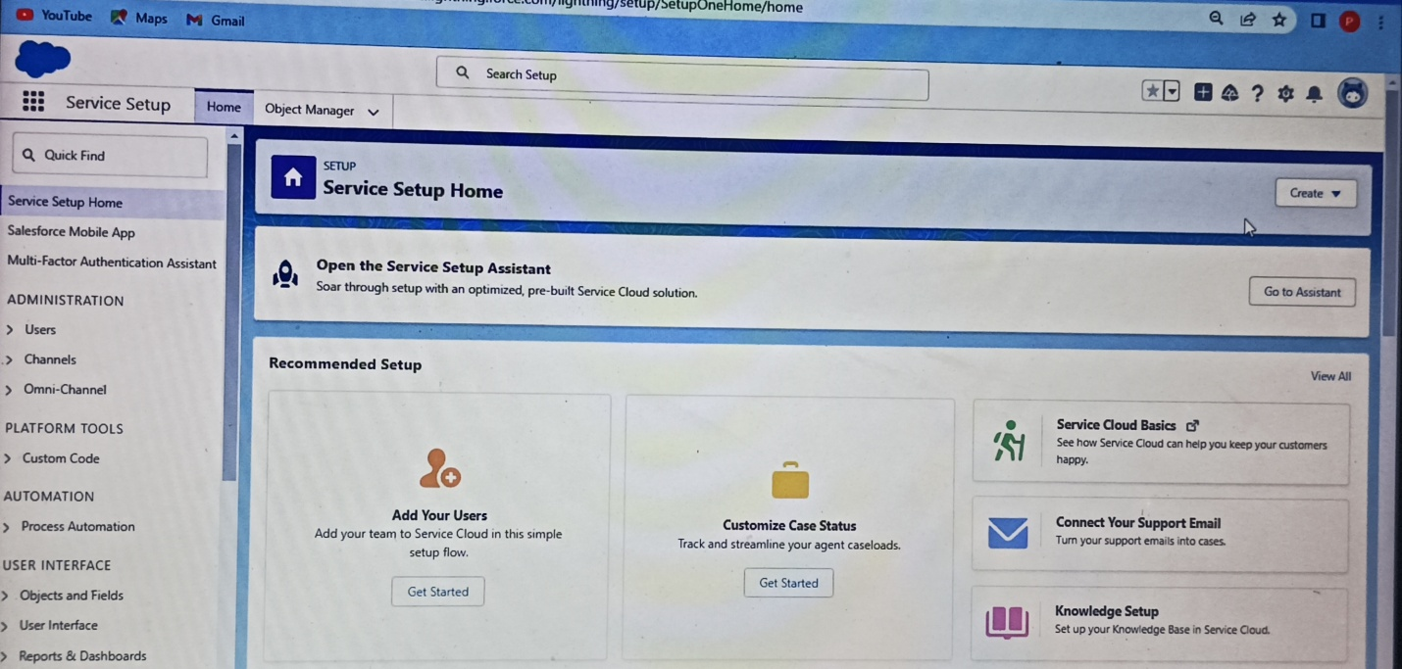

Creation of Users:

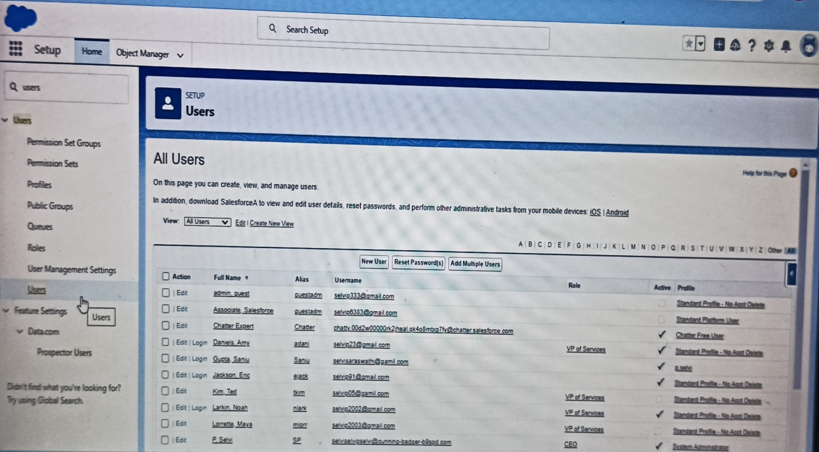

**4. Trailhead Profile Public** [**URL:-**](URL:-)

**Team Lead-** [**https://trailblazer.me/id/selvip2003**](https://trailblazer.me/id/selvip2003)

**Team Member 1-** [**https://trailblazer.me/id/rsneha14**](https://trailblazer.me/id/rsneha14)

**Team Member 2-** [**https://trailblazer.me/id/swathi463**](https://trailblazer.me/id/swathi463)

**Team Member 3-** [**https://trailblazer.me/id/srida20**](https://trailblazer.me/id/srida20)

**5. ADVANTAGES & DISADVANTAGES:**

Human Resource Management refers to management of employee working within the organization. It is part of management which aims at maintaining efficient and competent workforce. Human Resource Management involves wide range of activities such as hiring, training, motivating, fixing compensation, promoting and firing employees.

**Human Resource Manager (HRM)**

**Advantages**:

1. Human resource planning
2. Hiring workforce
3. Retaining employees
4. Enhance organization effectiveness
5. Handles disputes and queries
6. Motivating employees
7. Improves employees relations

**Disadvantage:**

1. Costly setup
2. Recent origin
3. Unpredictability
4. Improper development programmes
5. Insufficient information

Advantage of Human Resource Management:-

Human Resource Planning

Human Resource Management (HRM) helps in estimating the right number of people required for carrying out the necessary activities of an organization. It analyses different work positions within a business for identifying the skill sets needed for such positions. Proper information regarding job designations helps in acquiring the right peoples.

Retaining Employees

Human Resource Management plays an efficient role in retaining skilled employees for a longer term within an organization. It monitors working environment that they get hygienic working place, better remuneration, extra benefits and facilities. This leads to long term associations of workers with organization.

Improves Employee Relations

HRM focuses on establishing good relations among management and labors for ensuring continuity of business. It provides fair remunerations to workers and take cares of all their necessities. Human Resource Management builds up better coordination in between employer and employees by considering their ideas and suggestions in policy making.

Disadvantages of Human Resource Management:

Costly Setup

Human Resource Management systems require huge costs for installation within the business origination. Owners need to give proper training to its workers for setting up and running these systems. Small business can’t afford to run these systems within their operations.

Insufficient Information

Lack of essential information about workers adversely affects the performance of Human Resource Management systems. These systems require proper database of employees before implementing them. Many organizations do not maintain a proper data of their workforce and therefore need to acquire, retrieve and store the required information.

**APPLICATIONS:-**

Human Resource Management and operations easier and more efficient.

1. Employee database

One of the fundamental features of human resource applications is their ability to store each employee’s data. This consists of social security numbers, past employment details and each workers contact information.

1. Benefits administration

A core platform also has features for managing employee benefits. This includes 401k enrollment, life insurance policies, and healthcare programs like medical and dental plans.

1. Payroll management

The system can manage employee salaries, contributions made to a retirement program, bonus information and healthcare deductions. It will also facilities tax payments and direct deposits. Every company needs to run payroll, so this is a non-negotiable feature for those who don’t already have the process managed.

**Conclusion:**

**Human Resource Management (HRM)** plays a very significant role in the daily life. On the one hand, the soft and hard Human Resource Management influence on the business and lets them development rapidly. It can improve employees motivation in a business and pay attention to company’s policy and law respectively, which can increase the efficiency of company and get higher profits. On the other hand, trade unions help the employee to achieve negotiation a better wages and a good working condition.

**FUTURE SCOPE**:

Human Resource Management (HRM) professionals are termed as the backbone of an organization. There is a huge demand for such professionals in both the public and private sectors. No matter if you’re looking at startups or big reputed companies, human resource play a crucial role in the formation of a company’s future. The Human Resource Management department basically is the team that helps an organization increase productivity while also maintaining employee satisfaction.